44.43: a) 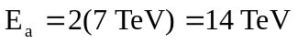
b) Fixed target; equal mass particles,
